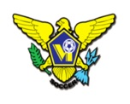 | USVI SOCCER ASSOCIATION  OFFICE: 340.719.9707 23-1 Estate Bethlehem, Kingshill, St. Croix 00850  USVISOCCERASSOCIATION@GMAIL.COM
IMMEDIATE RELEASE
September 15, 2022
U.S. Virgin Islands Soccer Association Coaching Education Pathway
The US Virgin Islands Soccer Association (USVISA) is excited to announce the new coaching education pathway which is designed to support coaches at all levels of the game. As part of the implementation of the new pathway, the coaching education department will host a Grassroots Coach’s Course throughout the territory during September 20-22, 2022.
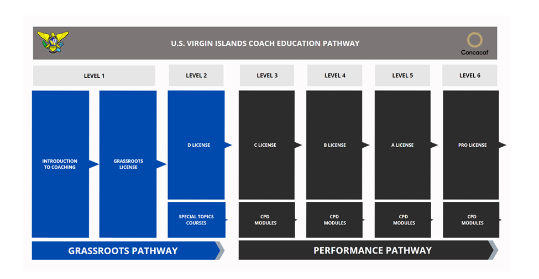

These Grassroots coaching courses are the first, in a series of courses that initiate the implementation of the new U.S. Virgin Islands Soccer Coaching Education Pathway.

Grassroots Coaching Courses
As part of our new coaching education pathway, the U.S. Virgin Island Coaching Education Department will be delivering the following Level 1 Grassroots Coaching Course. These courses are designed to support Grassroots coaches in creating fun, engaging, and developmentally appropriate training sessions.

GRASSROOTS COACHING COURSE SCHEDULE
Course Date | Course Level | Time | Location
Sept. 20 | Level 1 | 5:30pm-7:30pm | STX - Bethlehem Soccer Complex
Sept. 21 | Level 1 (All-Female) | 5:30pm-7:30pm | STX - Bethlehem Soccer Complex
Sep. 22 | Level 1 | 5:30pm-7:30pm | St Thomas (TBD)

Course Registration:
Please register for the course at - Course Registration Link

More Course Information:
For more information on USVI Soccer Association programs, please feel free to contact the USVI Soccer Association office at (340)-719-9707 or email us at usvisoccer@gmail.com. Follow us on Facebook at: USVI Soccer Association

