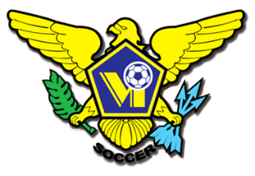 USVI SOCCER ASSOCIATION PRESS RELEASE
This Photo by Unknown Author is licensed under CC BY-SA
This Photo by Unknown Author is licensed under CC BY-SA
This Photo by Unknown Author is licensed under CC BY-SA
This Photo by Unknown Author is licensed under CC BY-SA
OFFICE: 340.719.9707 23-1 Estate Bethlehem, Kingshill, St. Croix 00850
USVISOCCERASSOCIATION@GMAIL.COM FACEBOOK/USVI SOCCER ASSOCIATION
IMMEDIATE RELEASE
November 12, 2021

USVI Soccer Association U-20 Male National Team Complete Campaign at Concacaf Qualifiers

The Dashing Eagles Under-20 male delegation’s campaign at the qualifying round of the Concacaf Men’s Under-20 Qualifiers, happening in the Dominican Republic from November 5-13, 2021, has ended.
The team played three tough matches, without a win. Suffering the greatest defeat to Nicaragua; the highest ranked member of group D, (7-0), in the first match, with a 4, 4, 3 formation. A red card was given to Guyana in the second game. Unfortunately, the advantage of having one more player on the pitch and defensive 5, 4, 1 formation was not capitalized on by USVI. Naqwan Henry scored in the 57th minute in the 5-1 loss. Arthbert William and Naqwan Henry got their names on the score sheet during the third and final loss, against Cayman Islands (5-2). Dashing Eagles were one of eighteen men’s U-20 teams participating in the Qualifiers (all ranked seventeen and below based on the current Concacaf Men’s U-20 Ranking) who were placed into two groups of five teams and two groups of four teams, in September 2021.
You can see complete matches and highlights of Team USVI on Concacaf.com, YouTube and Facebook.

For more information on USVI Soccer Association programs, please feel free to contact the USVI Soccer Association office at (340)-719-9707 or email us at usvisoccer@gmail.com. Follow us on Facebook at: USVI Soccer Association

