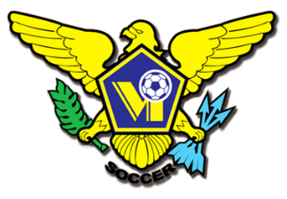 USVI SOCCER ASSOCIATION PRESS RELEASE
This Photo by Unknown Author is licensed under CC BY-SA
This Photo by Unknown Author is licensed under CC BY-SA
This Photo by Unknown Author is licensed under CC BY-SA
This Photo by Unknown Author is licensed under CC BY-SA
OFFICE: 340.719.9707 23-1 Estate Bethlehem, Kingshill, St. Croix 00850
USVISOCCERASSOCIATION@GMAIL.COM FACEBOOK/USVI SOCCER ASSOCIATION
IMMEDIATE RELEASE
August 26, 2022

USVI Soccer Association will host FIFA Delegation
The US Virgin Islands Soccer Association’s (USVISA) President Hillaren Frederick and the members of the Executive Committee will host a FIFA Delegation of Infrastructure Specialists on August 27, 2022.
The Delegation will be inspecting the Bethlehem Soccer Complex (BSC) in Estate Bethlehem on St. Croix USVI. Capital Improvement projects at the property are funded by a financial assistance program available to members of the FIFA network. FIFA Forward Program’s aim is to give custom-designed assistance for soccer development worldwide.

There are three completed structures at the facility:
- FIFA Professional Grade Artificial Turf
- Viewing Stands – 1200 Person Capacity
- Offices and Conference Center Building
- Home Team, Away Team, and Match Officials Locker Room Building
- Concession and Public Rest Room Building

Additional developmental plans include a fitness center and dormitories.

Members of the FIFA Delegation are:
Alejandro Calvente- Development Programmes Manager
Hervé Blanchard – Regional Office Development Manager
David Rosa – FIFA Infrastructure Consultant
Malaika Church- Regional Office Development Coordinator

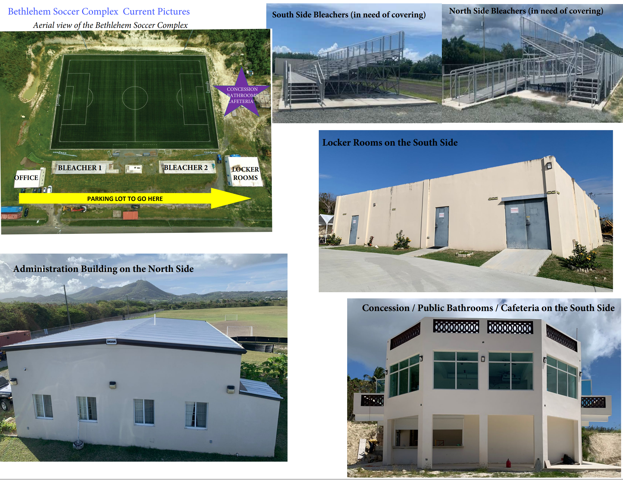

Click for more information on FIFA Forward Program FIFA .

For more information on USVI Soccer Association programs, please feel free to contact the USVI Soccer Association office at (340)-719-9707 or email us at usvisoccer@gmail.com. Follow us on Facebook at: USVI Soccer Association

