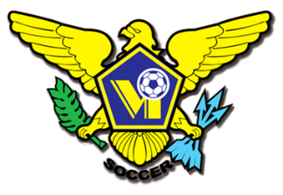 USVI SOCCER ASSOCIATION PRESS RELEASE
This Photo by Unknown Author is licensed under CC BY-SA
This Photo by Unknown Author is licensed under CC BY-SA
This Photo by Unknown Author is licensed under CC BY-SA
This Photo by Unknown Author is licensed under CC BY-SA
OFFICE: 340.719.9707 23-1 Estate Bethlehem, Kingshill, St. Croix 00850
USVISOCCERASSOCIATION@GMAIL.COM FACEBOOK/USVI SOCCER ASSOCIATION
IMMEDIATE RELEASE
May 13, 2022

GROW THE GAME COLLABORATION
U14 BOYS - YOUTH FESTIVAL

The US Virgin Islands Soccer Association’s and St. Croix AYSO are hosting a U14 Boys Soccer Festival on Saturday May 14, 2022, at the AYSO Soccer fields. Registration is at 3:15PM and games start at 3:30PM.
This one-day event is a pilot program aimed at starting a U14 boys’ league to allow kids to play and to facilitate the Youth boys’ National team selection for an upcoming tournament in August 2022.
A Youth National team calendar for practice and games will be released after the Festival.
For more information on USVI Soccer Association programs, please feel free to contact the USVI Soccer Association office at (340)-719-9707 or email us at usvisoccer@gmail.com. Follow us on Facebook at: USVI Soccer Association

