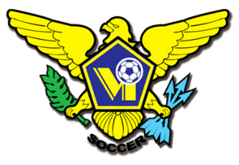 USVI SOCCER ASSOCIATION PRESS RELEASE
This Photo by Unknown Author is licensed under CC BY-SA
This Photo by Unknown Author is licensed under CC BY-SA
This Photo by Unknown Author is licensed under CC BY-SA
This Photo by Unknown Author is licensed under CC BY-SA
OFFICE: 340.719.9707 23-1 Estate Bethlehem, Kingshill, St. Croix 00850
USVISOCCERASSOCIATION@GMAIL.COM FACEBOOK/USVI SOCCER ASSOCIATION
IMMEDIATE RELEASE
Carol D. Howell – USVISA COMMUNICATION CHOWELL@USVISOCCERASSOCIATION .COM September 25, 2021

WOMEN NATIONAL TEAM TRAINING
The US Virgin Islands Soccer Association (USVISA) is holding practice sessions for female athletes interested in representing the USVI at International Soccer Tournaments. The selection of provisional players for Concacaf Women's Qualifiers Games in November 2021, with Guatemala and Costa Rica will start shortly.
Practice sessions are held at the Bethlehem Soccer Complex on St. Croix. Practice days are Mondays, Wednesdays and Fridays from 6:30PM to 8:00PM.
Come be a part of USVISA’s team of passionate Coaches, and administrators committed to our mission of providing positive developmental opportunities to the USVI community.
To register and get more information please contact USVISA Team Manager Bernetta Brown at USVIwomensmanager@usvisoccerassociation.com.
For more information on other USVI Soccer Association programs, please feel free to contact the USVI Soccer Association office at (340)-719-9707 or email us at usvisoccer@gmail.com. Follow us on Facebook at: USVI Soccer Association

Please add this press release to your sports brief and your community calendar. Thanks for your cooperation.

