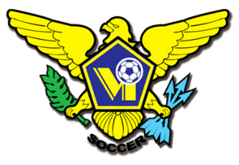
USVI SOCCER ASSOCIATION
This Photo by Unknown Author is licensed under CC BY-SA
OFFICE: 340.719.9707 23-1 Estate Bethlehem, Kingshill, St. Croix 00850
USVISOCCERASSOCIATION@GMAIL.COM FACEBOOK/USVI SOCCER ASSOCIATION
IMMEDIATE RELEASE
September 15, 2022
U.S. Virgin Islands Coaching Education Pathway
The U.S. Virgin Island Soccer Association is committed to the development and education of coaches at all levels of our soccer pathway. As part of our National Development Plan, and pursuit to be aligned with CONCACAF Coaching convention standards, the U.S. Virgin Island is excited to announce our National Coaching License Pathways.
Our Coaching License Pathway is designed to support the unique needs and goals of coaches at all levels of the game from Grassroots to our National Team Coaches. The goal of our coaching education pathway is to provide clarity on the educational opportunities and pathways for all coaches. Our courses are uniquely designed to equip coaches with the knowledge, skills, and resources to create developmentally appropriate training environments. Our coaching license pathway will provide our coaches with the education they need to meet the needs of our players at their stage of development. 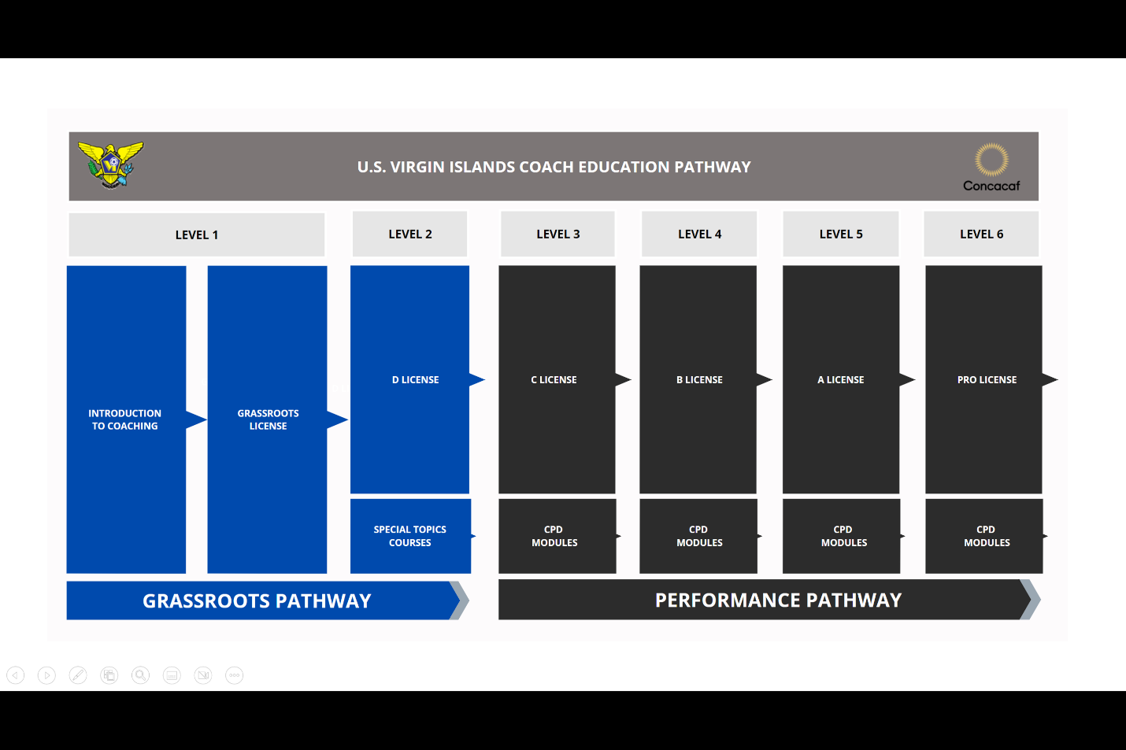

Our Coaching education department believes that “education is one of the most important and powerful tools we have to positively influence the soccer landscape and maximize the experience and development of players, coaches, referees, and parents at all levels.
Our leadership and technical department are committed to investing the resources necessary to ensure that the U.S. Virgin Islands delivers high-quality educational experiences for coaches at all levels.

For more information on USVI Soccer Association programs, please feel free to contact the USVI Soccer Association office at (340)-719-9707 or email us at usvisoccer@gmail.com. Follow us on Facebook at: USVI Soccer Association

