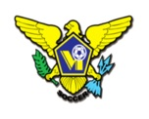 | USVI SOCCER ASSOCIATION  OFFICE: 340.719.9707 23-1 Estate Bethlehem, Kingshill, St. Croix 00850  USVISOCCERASSOCIATION@GMAIL.COM
IMMEDIATE RELEASE
November 30, 2022
Youth Small Sided Games Festival
The US Virgin Islands Soccer Association (USVISA) is all set to host the first - 4v4 Youth Progressive Small Sided Games Festival on St. Croix – December 3, 10, and 17, 2022 at the Good Hope Country Day School. Girls and boys fourteen years or younger can participate in this tournament that aligns with the USVISA’s mission to Grow the Game of Soccer.

The Youth games are an opportunity for USVI youth to play soccer and to display their talent. It is also important to highlight the need to Grow the Game in the territory by creating more opportunity in the following areas: 1. Club Development 2. Coach Development 3. Player Development 4. Referee Development 5. Volunteers growth 6. Create CommUNITY relationships.

We want to have all members of the community involved; all skill levels are welcome to participate in our free family friendly games. Registration on match day is available.

There will be entertainment, food and drinks for sale, bouncy houses, face painting and giveaways. In one word, Fun!

Match Schedule:

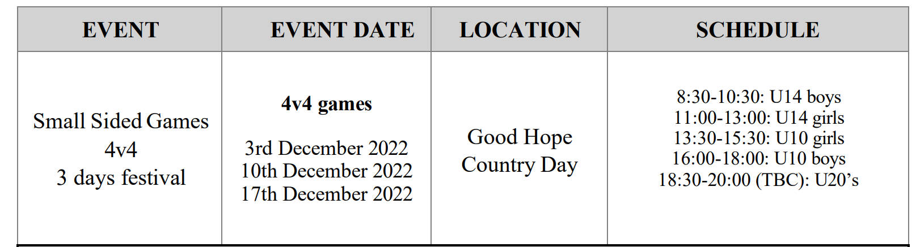

For more information on USVI Soccer Association programs, please feel free to contact the USVI Soccer Association office at (340)-719-9707 or email us at usvisoccer@gmail.com. Follow us on Facebook at: USVI Soccer Association

