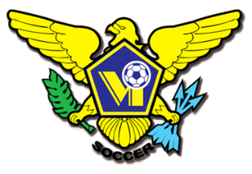 USVI SOCCER ASSOCIATION PRESS RELEASE
This Photo by Unknown Author is licensed under CC BY-SA
This Photo by Unknown Author is licensed under CC BY-SA
This Photo by Unknown Author is licensed under CC BY-SA
This Photo by Unknown Author is licensed under CC BY-SA
OFFICE: 340.719.9707 23-1 Estate Bethlehem, Kingshill, St. Croix 00850
USVISOCCERASSOCIATION@GMAIL.COM FACEBOOK/USVI SOCCER ASSOCIATION
IMMEDIATE RELEASE July 6, 2021

SOCCER GRASSROOTS FESTIVALS
The USVI Soccer Association Soccer Grassroots Festival program continues on St. Croix every Saturday morning from 9:00AM – 12:00PM at the following locations:
Whim Ball Park, DC Canegata and the Bethlehem Soccer Complex.
On St. Thomas, the Soccer Grassroots Festival is as follows:
July 10th - Oswald Harris Court July 17th - Kirwan Terrace
July 24th - Smith Bay Ballpark July 31st - Griffith Park ( Festival)
Support and participation during the initial round of community-based Grassroots Festivals was phenomenal. Thank you to the residents of Oswald Harris Court, Kirwin Terrace, Bovoni/Thomasville/Nadir, Annas Retreat, Frydenhoj, D. Canegata Ball Park, John F. Kennedy Terrace, Estate Profit, Grove/D. Hamilton Jackson Center, and Whim Gardens. With your support the USVI Soccer Association will continue to Grow the Game of Soccer in the US Virgin Islands.
The USVI Soccer Association Grassroots Program is for all kids...
It can be played everywhere, anywhere, anyhow...
It teaches life skills... It is fun...
It is where the future USVI player will start the Soccer journey...
USVI Department of Health and USVI Soccer Association COVID Guidelines will be followed. All participants must wear masks, use sanitization stations, and wear athletic attire. Refreshments and prizes will be given out.
For more information on USVI Soccer Association programs, please feel free to contact the USVI Soccer Association office at (340)719-9707 or email us at usvisoccer@gmail.com. Follow us on Facebook at: USVI Soccer Association

