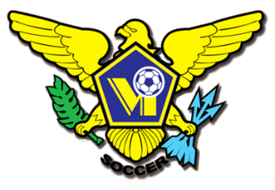 USVI SOCCER ASSOCIATION PRESS RELEASE
This Photo by Unknown Author is licensed under CC BY-SA
This Photo by Unknown Author is licensed under CC BY-SA
This Photo by Unknown Author is licensed under CC BY-SA
This Photo by Unknown Author is licensed under CC BY-SA
OFFICE: 340.719.9707 23-1 Estate Bethlehem, Kingshill, St. Croix 00850
USVISOCCERASSOCIATION@GMAIL.COM FACEBOOK/USVI SOCCER ASSOCIATION
IMMEDIATE RELEASE
June 3, 2022
USVI Dashing Eagles Draw 1-1 With St. Maarten
The US Virgin Islands Soccer Association’s (USVISA) Men National Team began their 2022/23
Concacaf Nations League presented by Qatar Airways campaign on a positive note with a 1-1 draw against St. Maarten.

Head Coach Giba Damiano and his staff were confident going into today’s match that the final result would show the changes that have been taking place within the Senior Men program would be evident on the pitch. A good performance and results were what was required of the team.

J.C. Mack scored early for the Dashing Eagles, in the eighth minute. The lead was defended well for much of the Match. St. Maarten’s Captain Kay Gerritsen, equalized with eight minutes of regulation time left to play.

The Dashing Eagles are playing in League C of the CNL in Group A. The other Group A teams Bonaire, and Turks and Caicos Islands match ended 4-1 in favor of Bonaire.
The team returns to the territory on June 4, 2022, for two home matches in five days at the Bethlehem Soccer Complex. Turks and Caicos Islands on June 6 and Bonaire on June 11. Start time for both days is 4:00PM. Tickets must be purchased online at Eventbrite. Tickets will not be available for purchase at the venue. Adult tickets are $20.00 and children under 12 years, $8.00.
https://usvimnt2022concacafmensnationsleague.eventbrite.com/

For more information on USVI Soccer Association programs, please feel free to contact the USVI Soccer Association office at (340)-719-9707 or email us at usvisoccer@gmail.com. Follow us on Facebook at: USVI Soccer Association

